THE FUTURE OF
SMART GARDENING
STARTS HERE.



project title:
SMART ECO SYSTEM
TEAM:
Declan Bell, Dorota Marczak, Scott Alan, Nader Sobhi
Outline Business Case & project plan
Version Number: 1.0
Version Date: 20.09.2018

DDNS Ltd., an information technology company located at Abertay University, DD1 1HG Dundee, is pleased to provide this IT Project Proposal to Lynsey Shepherd, the CEO of Abertay Plant System with the headquarter in Dundee.
By the signature of DDNS Ltd. authorized representative hereunder, this IT Project proposal constitutes a formal offer to provide the deliverables described herein on the terms and conditions described herein.
VERSION HISTORY

Version  Number | Implemented  By | Revision  Date | Approved  By | Approval  Date | Description of  Change
1.0 | Whole team | 09/20/18 | Dorota Marczak | 09/20/18 | The executive summary
1.1 | Dorota Marczak & Scott Allan | 09/27/18 | Dorota Marczak | 09/27/18 | The introduction
1.2

TABLE OF CONTENTS
1 Executive Summary 5
2 Introduction [from here you will be mainly looking at steps 1-3 from the stepwise planning approach discussed in the lecture; answering the questions discussed for each step will help with filling in sections 2-6 of the Proposal Template.] 6
2.1 Purpose of this Document 6
3 gENERAL Project iNFORMATION 6
3.1 Project Description 6
4 High-level Business Impact 7
5 aLTERNATIVES and aNALYSIs 8
6 Preferred Solution 8
6.1 Preliminary Work Breakdown Structure 8
6.2 Assumptions and Constraints 9
7 Detailed PROJECT PLAN [Here you will be mainly looking at steps 4 and ownards from the stepwise planning approach] 9
7.1 Product Breakdown Structure (a visual aid) 9
7.2 Activity Plan (a visual aid) 9
7.3 Resource Allocation and Timeline 9
7.4 Identification of Critical Path 9
7.5 Identification of Costs and Benefits 10
7.6 Justification of Project Approach & Project Methodology 10
7.7 Version Control and Requirements Changes 10
7.8 Quality Assurance and Test Plan 10
7.9 Risk Management Plan 10
8 References 11
Appendix A: Approval 12
Appendix B: Key Terms 14
Appendix C: Team Rules and Roles 15
Appendix D: Minutes & Reflection 16
Appendix E: Peer Assessment 17
Appendix F: Artefact or prototype material 18

1 Executive Summary
The client, Lynsey Shepherd, representing Abertay Plant System, has identified the need for a Plant Monitoring System which will monitor the light, temperature, humidity and moisture levels of a plant, that will then be commercially produced. DDNS Ltd., an IT firm proficient in designing and implementing IoT and smart technologies, have been tasked with developing a system that meets this goal. The system requested should also meet a number of secondary goals which are defined as follows. Firstly, the solution should be effective, reliable and low-cost. Secondly, the system should be controlled remotely via a user friendly web portal. The web portal should also be able to communicate the needs of the plants to the user, such as if the temperature is too hot or the light level too low. Thirdly, the system should produce useable data and clear statistics that will aid in optimising the plant’s environment. Finally, the system should be fully documented to ensure clear terms of operation.
Aim of the Project
The client defined the optimisation of the small plants’ growth as the main goal of the project. This goal will be achieved by combining the vegetation and plantation knowledge of Abertay Plant System with the cutting-edge system delivered by DDNS Ltd. The final product is expected to perform measurements and record environmental factors (temperature, light level, humidity & soil moisture level), which then will be stored in a relational database and displayed via a bespoke web portal.
Development process – Methodology
-DEFINE METHODOLOGY
The development process will begin with the team getting acquainted with the requirements provided by the customer, which will then be followed by client consultations. This will help to clarify the mental model of the future product. The project will be developed in regular collaboration with the client, as this is a critical part of the chosen development methodology. Also, the workflow will be easy to control via an online application providing flexibility of team work.
When the prototype is ready, the proper tests will take place and the feedback from the Project Owner will be requested. At the end, one of the team members will be in charge of preparing a short report including client’s recommendations/requests, as well as any obstacles that were faced and extra notes. The above process will be repeated until a final release.
Potential risks and backup plan
One of the most probable risks related to the project is delay in releasing a fully-functioning product. However, above risk will be minimalised by a rigid work organization and task decomposition. Another issue that may appear during the process is exceeding the budget. This risk, in turn, may be reduced by keeping track of all the necessary hardware and software components. Last but not least, the customer may change his mind and vastly redefine the requirements. To mitigate the above problem we will keep in constant communication with the client, when possible, as this will be a great way to make sure we are on the right track.
Performance indicators & success defining
The product should be available at all times, perform as required and maintain a high level of quality output
Availability = There should be no system downtime as this may significantly impact upon the health of the plant
Performance = The product should perform as expected and aim to exceed user expectations where possible
Quality = The product should produce high quality output consistently that is useful to the user. This should be easy to interpret and provide the user with sufficient feedback to make informed decisions

Mapping key performance indicators onto business objectives
The product should be available at all times, perform as required and maintain a high level of quality output
The user must have the ability to view the real-time situation of the plant as well as historical data. This will be available through the web portal and must always be available. Pertinent data must be made available on request.
There should be no system downtime as this may significantly impact upon the health of the plant
In order to monitor the plant and ensure it stays in optimal health, the system must be operational at all times. This includes the Arduino board, attached sensors, the database and the web portal.
The product should perform as expected and aim to exceed user expectations where possible
Success of the product depends largely on the user interacting with the system in an intuitive and meaningful manner. The product should provide relevant information that will aid in maintaining an optimal environment for the plant to thrive.

The product should produce high quality output consistently that is useful to the user. This should be easy to interpret and provide the user with sufficient feedback to make informed decisions
Information should be displayed in an intuitive and readable manner via the web portal. Sufficient data should be provided to the user in order to adequately convey the current status of the plant’s health and allow them to determine whether they need to make any changes to the plant’s environment.
Benefits of selecting our company for the project include:
DDNS Ltd. are a talented team of IT specialists with a wide range of knowledge and key expertise in IoT and smart technologies. We are adept at providing cost-effective solutions that will satisfy the needs of the client. Throughout the design, development and implementation process, client collaboration plays a key role in addressing any concerns as well as making them emotionally invested in the product and keeping them up to date with current developments and features.
About DDNS
DDNS Ltd. is a leading provider of expert Smart Technologies to local businesses in Scotland. The company boasts to have served an ever-growing number of clients relying on our experience in the IT field and time-efficient work organization, which gives the ability to complete projects on time and within the customer’s budget.
Contact details:
- Dorota Marczak  Role: Project Manager & Application Developer  Telephone number: 01234567899  Email: email@email.com | - Nader Sobhi  Role: Application Developer  Telephone number: 01234567899  Email: email@email.com
- Scott Allan  Role: Application Developer  Telephone number: 01234567899  Email: email@email.com | - Declan Bell  Role: Application Developer  Telephone number: 01234567899  Email: email@email.com

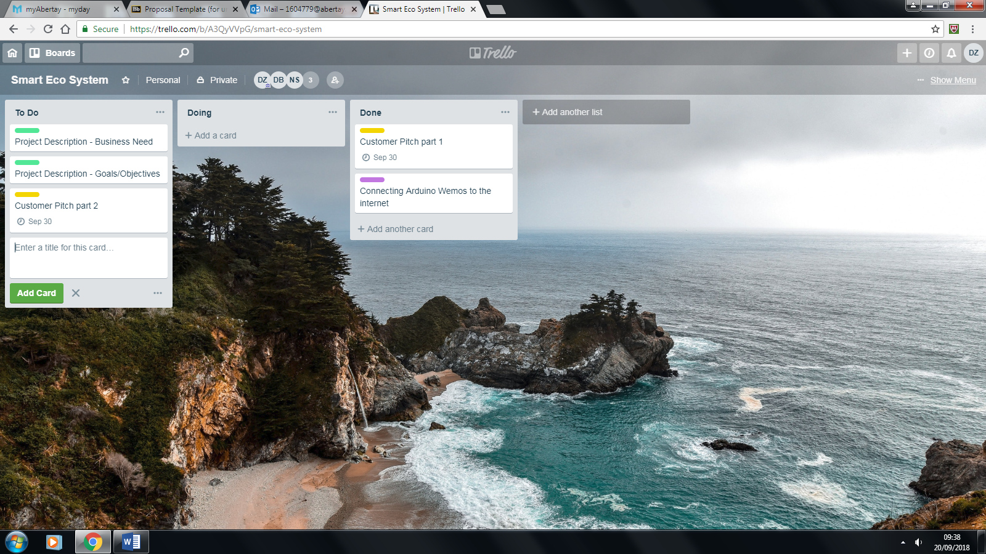

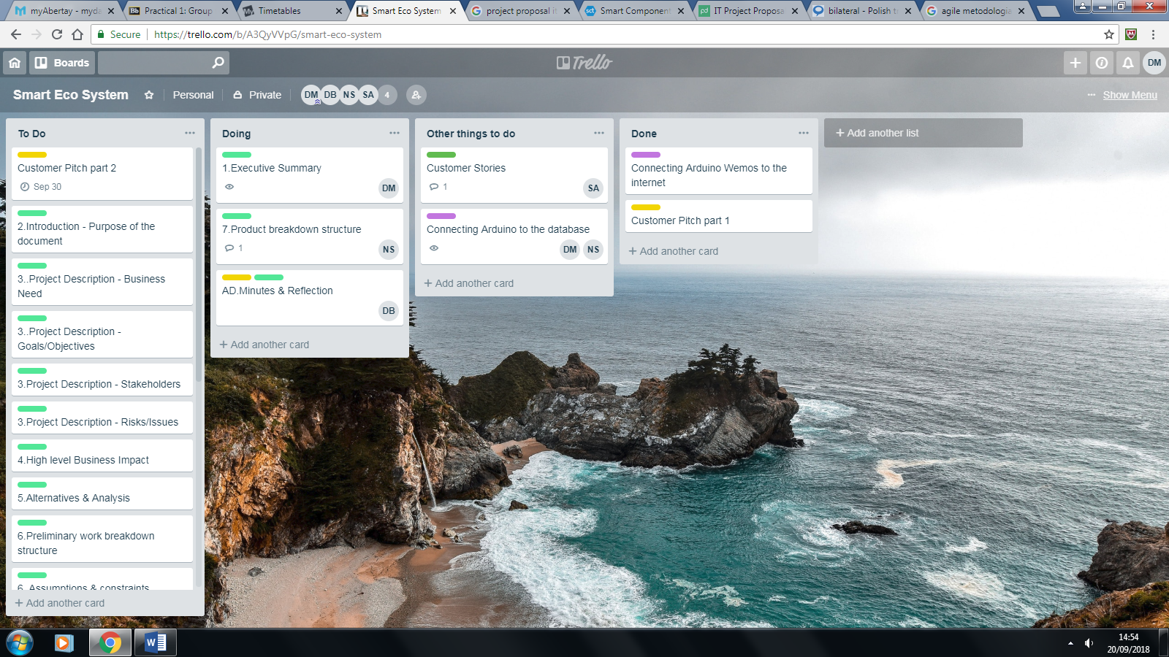

2 Introduction

Purpose of this Document

The purpose of the document is to provide the justification for undertaking this project for Lynsey Shepherd, CEO of Abertay Plant System, based on estimated costs, benefits and risks.

Throughout the development process, DDNS Ltd. team focuses on optimizing the costs of the devices and tools it is working on while preparing and implementing prototypes of the product, placing functionality over design.
As a company with long-standing experience, DDNS Ltd. is aware of the importance of determining the projects viability. The above-mentioned assessment cannot be solely based on the project costs, but also on time performance, quality of the final product, and last but not least, team availability and mobilization.
To meet those requirements, the company undertakes all the necessary steps on the way to the system optimisation. To start with, the database use is limited to the working hours. By doing so, database service cost is reduced by approx. 65% and the potential data wastage is avoided. Moreover, the team members are allowed to work no more than 8 hours a day due to health guidelines and have all the necessary tools and facilities provided.
In addition, the viability of the project is constantly monitored by the Project Leader, making sure the budget is not exceeded and the project is on the right track. The Project Leader is also responsible for calling team meetings twice a day to gather project updates, as well as keeping the client informed and helping them to actively participate in every stage of the project.

general project information

Submission Date | 29 November 2016
Requested By | Lynsey Shepherd
Business Owner | Andrea Szymkowiak
Contact Info. | 1604779@uad.ac.uk, 01234567899
Project Name | Smart Eco System
Desired Start Date | 9 January 2018
Desired End Date | 18 April 2018

3 Project Description

Business Need
We were approached by Lynsey Shepard, CEO and representative of Abertay Plant Systems. The company produces gardening accessories that can be purchased to aid in customers daily gardening needs. Their main business lies in creating these accessories and selling through various retailers as well as contracting other companies to create these devices which they will later sell and, if need be, to maintain them. The company requested this project as they wanted to expand their market into IoT devices and Smart Technologies, due to its surging popularity in recent years. The company also realised that there was a good opportunity to enter the market since the alternatives which are currently available to purchase are expensive and require custom hardware.
The project that will be developed will address the clients request to enter the market of IoT devices, this will be achieved by creating a prototype system to get an idea of how feasible the system would be on a commercial scale. In creating a prototype system we will have created an IoT device as well as the accompanying website, and database in order to provide the client with a fully functioning system and template that they can then use to create a commercial line for their product.
Fortunately, the data that will be collected by the IoT device is not sensitive information that would have to be encrypted or stored with a great emphasis on security. However, it is still data that is collected in people’s homes over long periods of time as the devices will have a very long uptime due to the nature of their operations, monitoring a plant. So in order to make sure that the device is compliant with the GDPR and other data regulations the user will have to accept the collection of data from their device when they use the web interface for the first time. If they choose to not accept the agreement then the device will delete the data that may have been collected will the device was in idle and not collect any future data. The data that will be collected will also be clearly outlined to the user in the agreement. Another piece of legislation that needs to be considered are copyright laws, this is due to the fact that we are using third party software and hardware for the creation and development of this system. However, the software and hardware we are using is open source under the European Union Public Licence and the Arduino Privacy Policy clearly states that the sale and distribution is authorised if your are the creator of the code and have purchased the devices legally.
Moving forward the benefits of the creation of this system for the client will be the procurement of a device and accompanying software that will be available to them that will allow the following benefits to the client; They will have a prototype device that will be the template for the devices that they go on to produce. They will have the code that will can then be put onto all the devices they will produce in the future. They will have a website which allow them and the users to monitor the plants well being and growth. Due to all this they will gain a reputation for creating functional and useful IoT devices, that are also inexpensive. They will also be able to integrate this product with their current business model of gardening equipment and tools.
Our relation to the client is through our University Course, as we are all students, there were reliable sources informing us that Lynsey Shepard a lecturer and part time entrepreneur wanted to hire or ask a team of developers to create a device and accompanying system that would push Abertay Plant Systems into the IoT sector. Upon hearing this we approached Lynsey as a group and asked if she would like us to undertake this project, she agreed and through a product brief we were provided gave us the basic outline of what she wanted to be included in the project. Our team is comprised of four individuals that are more comfortable with different aspects of system design and development but are still comfortable with the basics of all aspects. Since this is the case, we feel that we are the appropriate team for this project as the technical skills required for creating a system of this calibre, are right up our alley as they are things we had been doing in our Course. When interacting with the client we try to make sure that the whole group is present and we try to make sure that everyone in the group gets a chance to talk so as to make sure that there is not just one person talking with the client, this leads to there not being one leader or boss when it comes to client communication.
[Identify the client here – who are they, what type of organization do they work for, what is their main business, why did they want the project, etc.
Enter a detailed explanation of the business need/issue/problem that the requested project will address (business objective(s)).
Include regulations etc., for example, standards you and/or the client have to follow (e.g. ISO, legal, confidentiality issues, laws, acts etc.).
Include any expected benefits from the investment of organizational resources into the project for the client, i.e., not yourself. These should be generic but convincing (e.g. enhanced reputation, savings, secure systems etc.). NOTE: you will talk about the detailed costs and benefits in 7.5.
Describe how your team is related to the client (are you in the same organization as the client or outside the organization) - who are you? e.g., a student group at Abertay; what is your project team organization – how do you fit into this project? Who is ‘boss’, liaising with the client etc ].

Goals/Objectives
For a concise overview, the short-term, long-term, and operational goals will be outlined, as well as reiterating the objectives for our project in a more formal and expansive manner.

Short Term Goals
These include formulating a client pitch to describe the direction and final product of the overall project. We also aim to develop a basic, working prototype to illustrate the form and function of the final product. Alongside the prototype, a document outlining the detailed requirements, functions performed and physical components used will be produced.

Long Term Goals
The main long term goal is to produce a fully functioning Plant Monitoring System that will record all the required measurements from the sensors and input them into a relational database system. Alongside this, a web portal will be produced that allows intuitive and concise visualisation of the data held on the database.

Operational Goals
We aim to ensure we are using the most contemporary hardware as well as the most current software development techniques so as to ensure the product delivered is in line with current industry standards.

Objectives
Our client approached us saying that, like them, many people find it hard to plant and grow fauna indoors in today’s busy and frantic world saying that they find that the maintenance of a plant often slips their mind.
They continued to say that the IoT plant monitoring systems that already exist are expensive at upwards of £100 and are therefore not ideal for people who are starting to take on the hobby of plant keeping. They concluded that the cheaper alternative in the long run would be to ask us to develop an IoT device using Arduino boards and compatible sensors. These components are low-cost and versatile, vastly reducing the cost compared to an off the shelf unit. From the client story, we decided that this was a feasible project and a gap existed in the market for a low cost Plant Monitoring System. By using all this information, we were able to start to formulate a plan and plan our work to meet the clients requirements.
Enter a detailed explanation of how your proposed project aligns with, or advances, organizational goals and objectives, and avoids duplication of any enterprise architecture components. Here you are trying to reflect on the higher order organizational objectives and make them part of your plan and project objectives.]

Stakeholders
Client – Lynsey Shepard
Team Leader – Dorota Marczak
Team – Nader Sobhi, Scott Allan, Declan Bell
Target Audience – General Public
Communication with the client is carried out either face to face or by email. If a serious issue/concern is raised, face to face communication is sought in order to nullify any ambiguity. Progress reports, resource requests or general enquiries are generally handled via email. Any information requested or received is then relayed to the group via a messenger group or in person.
The team is led by Dorota Marczak, who oversees work progress and issues new tasks in an appropriate order where required.
[Identify the entities, components, and people that have an interest or influence on the project or will be impacted by its outcome, e.g. clients, people using what you develop, your team etc. Identify ‘who is boss’ in your team, and who you are mainly communicating with on the client side. In many cases this will be your subject specialist.
Briefly outline how you keep in contact with the relevant stakeholders (e.g. you may have regular meetings scheduled in your proposal), and communicate and disseminate information.]

Risks/Issues
[Discuss the main risk areas for your project. NOTE: There is a whole section dedicated to risks further below in your detailed plan (7.9). Here you outline relevant risk areas (e.g., staff, technology processes or organization) and briefly how you address them. ]
As with any project of comparable size, there is a number of risk areas and issues that occur.
Staff have the same frailties as any other person, they may fall ill during the course of the project, arrive late to planning or development settings or have work or family commitments. To mitigate this risk, regular progress meetings should be held, either digitally or in person, to ensure the project is on track and all staff are aware of the current project status.
Developing technology at any level carries with it the risk that a competitor will make it to market first, produce a cheaper solution or the technology itself becomes obsolescent. To counteract this risk, extensive research was done to ensure the solution did not already exist in the marketplace nor were there immediate plans to launch a product that was as cheap to build. The technology being implemented runs a very low risk of being rendered obsolete, as at its core, the project is little more than a website, circuit board, sensors and a database. However, data protection legislation is constantly evolving and may need to be something that is monitored to ensure compliance with the law.
4 High-level Business Impact
[Outline what business functions/processes may be impacted, and how, by the project for it to be successfully implemented.
Describe plans for addressing ongoing operations, future growth, and how this will be addressed and managed.
Consider the requirements for additional hardware, software, building materials, resource requirements, staffing, training, other expenditures, etc.
Describe how the performance of your project will be measured, and identify associated key performance indicators; describe how these address a particular business objective and/or need. Note: You will provide more detail on this in 7.8]

aLTERNATIVES and aNALYSIs
[The Alternative Analysis section should identify options and alternatives to the proposed project and the strategy used to identify and define them.
Do some research on the Internet/library systems – what other systems are out there? You need to reference what you discuss (there is a reference section at the end of the document).
Further analysis of these potential options should be performed to identify a preferred solution.
Include a description of the approaches for the identification of alternatives and an outline/description of each alternative considered. Include at least one viable alternative: e.g., keeping things “as-is” or reuse existing people, equipment, or processes; identify one as the preferred solution.
Some examples of alternatives to consider may include:
- Buy vs. build vs. lease vs. reuse of existing system
- Outsource vs. in-house development
- Commercial off the shelf (COTS) vs. Government off the shelf (GOTS)
- Mainframe vs. server-based vs. clustering
- Unix vs. Linux vs. Windows etc.
Clearly indicate your preferred solution – naturally, in this case, this has to be your project. ]
Alternatives and Analysis
We identified several different alternative smart plant monitoring systems, we chose 3 solutions with 2 being D.I.Y projects and the other a Kickstarter project that you can buy the full kit.
Option 1: Plant Monitoring System (Created by Ryan Gill, Hackster.io) ~$25
This system uses an Arduino MKR1000, temperature sensor, photo resistor and moisture sensor connected to a breadboard with a battery bank to power the device. The system uses the free open-source software Johnny-Five to control the sensors and send the data to the RethinkDB database.
Although this system is cheap, it does need a good understanding of how it works and how to set it up.
Option 2: Arduino Smart Plant Watering (Created by Elecrow, instructables.com) ~$135
The watering system created by Elecrow uses more or less the same components as option 1 but on a larger scale. This system has a 4 channel water valve for watering up to 4 plants at a time and doesn’t use a breadboard or jumpers. This system looks cleaner than the first option but it is more expensive, does not connect to a database to collect data and only has moisture sensors.
Option 3: SmartPlantPi (Created by SwitchDoc Labs) ~$20
The SmartPlantPi is a Kickstarter project is a watering system that uses a Raspberry Pi which uses the sensors to monitor the sunlight, air quality, temperature and humidity. Like the D.I.Y project by Ryan Gill, it has software to monitor everything, Amazon Alexa/Echo Dot compatibility and it is open source. This system looks easy to use for consumers but it is the most expensive out of the 3 and is no longer available.
Option 4: Smart Eco System (Created by DDNS) ~ $15
The Smart Eco System is the solution that we are creating, it consists of an Arduino Uno that has sensors attached to it that collect data on the plant, the UNO will then send the data collected to the database where the website will be able to access it and produce graphs and charts of the plants growth. This device and accompanying software will not require compatibility with any software or hardware that the user may already own as it is a standalone piece of equipment.
Preferred Option: Smart Eco System (Created by DDNS)
We believe that our solution is the best option due to the following reason:
- It is more inexpensive than the other options
- The code will be simpler
- Due to our relationship with the client we can easily add functionality to the device
- Our option will also be customisable due to the fact that there will be space on the device to add additional sensors

Preferred Solution

Preliminary Work Breakdown Structure
[Include a Work Breakdown Structure (WBS) for the preferred solution. The preliminary WBS organizes and defines 100% of the scope of project work to be accomplished and displays it in a way that relates work elements to each other and to the project’s goals. Consider what activities (e.g. requirements analysis, design, coding, scripting, performance tests, investigations, … ) you need to carry out to meet your proposed project objectives, (e.g. develop a honey pot, break into a network system, design a website, app etc.)

You may want to search the Internet for information on WBS, for example,
https://www.projectsmart.co.uk/work-breakdown-structure-101.php
https://www.workbreakdownstructure.com/

Also indicate briefly which methodology / approach you have chosen for your project, e.g. Waterfall, Incremental, Prototypes, Spiral, Agile etc. You talk more about this in section 7.6.]

Assumptions and Constraints
[An assumption is a guess as to what you can take as a given in your project, e.g., access to labs, availability of equipment etc. A constraint may be a limitation in relation to the project, e.g. no 24 hour access to labs etc.
Include a detailed explanation of any assumptions and constraints applied to the information within this document. You can consider factors such as, e.g., market demand for this product, tool etc., support available, something you need from the client, lab access etc. ]

Detailed PROJECT PLAN [Here you will be mainly looking at steps 4 and ownards from the stepwise planning approach]

Product Breakdown Structure (a visual aid)
[Indicate what products you want to deliver in a breakdown structure diagram. In addition to code/website/tool/documentation on exploits/vulnerabilities/tutorials etc. this will also include the white paper at the end of CMP311 (the follow-up module), as it is a document you hand over to the client. Note that you have about 12 weeks to actually work on the product in Term 2 for CMP311. Describe the main products.]

Activity Plan (a visual aid)
[Insert an activity plan diagram. What are your activities? Think about the order in which you need to conduct activities. Describe the main components.]

Resource Allocation and Timeline
[Insert a resource plan (some visualization, e.g. Gantt chart).]

Identification of Critical Path
[Insert an activity / Precedence network diagram to identify the critical path in your project. Describe the critical path briefly.]

Identification of Costs and Benefits
[Describe costs and benefits for the client.
Remember: Costs and benefits may not necessarily be monetary, but can be. You can make costs up if you like if you want to charge the client (this obviously will not happen in your project). ]

Justification of Project Approach & Project Methodology
[Discuss why your chosen project approach (SCRUM, waterfall, spiral etc.) is appropriate for your project and why other approaches are not appropriate. Your argumentation should make reference to project features (e.g. available time, difficulty of the project, complexity and uncertainty, for example.]

Version Control and Requirements Changes
[Discuss how you would deal with version changes and communication of those within the team and relevant stakeholders.]

Quality Assurance and Test Plan
[Discuss how you would test the quality of your project. Consider, for example, ISO standards, usability or legal issues, etc. You need to identify how you make sure your project is up to the required standard. Consider also what variables are you collecting to make sure you can objectively say your project is successful (e.g., number/percentage of exploits detected – what would be an optimum number/percentage compared to a known baseline? Or a survey score – what would you want to achieve in terms of usability if you designed a website and what standards do you have to follow? Or how do you make sure your code is reasonably error free, your product ‘behaves’ as it is meant to behave etc.) ]

Risk Management Plan
[Discuss your identified risks in detail. These might be, for example: Staff, Schedule, Initial Costs, Life-cycle Costs, Technical Obsolescence, Feasibility, Reliability of Systems, Dependencies/Interoperability, Surety Considerations, Future Procurements, Project Management, Overall Project Failure, Organizational/Change Management, Business, Data/Information, Technology, Strategic, Security, Privacy, Project Resources.]

Discuss how you would deal with the identified risks; use some sort of visualization, e.g., a risk matrix etc. to illustrate the most sever risk you need to monitor.]

References
[Insert your references here. References may arise from section 5, for example, when you research alternative solutions for the project brief.
Use a consistent format, e.g. Harvard (or whatever the University is using) - http://www.citethisforme.com/harvard-referencing, but any format is fine as long as you use it consistently for your references. ]

http://ec.europa.eu/idabc/servlets/Doc027f.pdf?id=31096
https://www.arduino.cc/PrivacyPolicy/en/

Appendix A: Approval
The undersigned acknowledge that they have reviewed the <Project Name> Project Proposal and agree with the information presented within this document. Changes to this document will be coordinated with, and approved by, the undersigned, or their designated representatives.
[List the individuals whose signatures are desired. Here, team members, clients etc. should be listed. Add additional lines for signatures as necessary. This form should be signed and scanned into the document. NOTE: You need to get a real signature from the client, so make sure you get this in due course so you can submit the proposal.]

Signature Team Member: |  | Date:
Print Name:
Role:

Signature Team Member: |  | Date:
Print Name:
Title:
Role:

Signature Team Member: |  | Date:
Print Name:
Title:
Role:

Signature Team Member: |  | Date:
Print Name:
Title:
Role:

Signature Team Member: |  | Date:
Print Name:
Title:
Role:

Signature Client: |  | Date:
Print Name:
Title:
Role:

Appendix B: Key Terms

The following table provides definitions and explanations for terms and acronyms relevant to the content presented within this document.
Term | Definition
[Insert Term] | <Provide definition of term and acronyms used in this document.>

Appendix C: Team Rules and Roles

[List what your team rules are – for example, how do you deal with absences, disagreements; do you have a democratic decision making process etc.

List what your individual team members’ roles are, e.g. keeper of minutes, developer, manager, designer, coder etc.]

Appendix D: Minutes & Reflection

[This section should contain detailed minutes of meetings.
This should comprise:
- Date, time and venue of the meeting
- Who is present
- Any absences and apologies received
- Approval or amendments of previous minutes if available (review)
- A description of what is discussed and agreed upon (or not) in the current meeting
- Any challenges flagged up (in the team) and how were they addressed
- Actions for next meeting
- Date, time and venue for next meeting

There should also be a brief section on the atmosphere/challenges within the team, how team dynamics were addressed etc.
]

Appendix E: Peer Assessment

Name (print) for each team member (including yourself) | Each team member should individually and confidentially upload this form to BlackBoard, using the ‘Peer Assessment’ link in Blackboard (via ‘Submit Module Assessment and Deliverables under Assessment information). Each team member should select a mark from 0, 0.5, 1, 1.5, 2, 2.5, 3, 3.5, 4, 4.5 to indicate how well they think the other team members have contributed to the TEAM WORK (you also give a mark for your own contribution to the project to yourself).

Appendix F: Artefact or prototype material

[This section can contain preliminary work, e.g. website pages prototypes, code, a selection of tools, images of displays etc.
]

